CIS5430 Mid-Term Exam

Name__Raymond Delgado________________

Part I. Vacation Property Rentals organizations rent the types of properties.

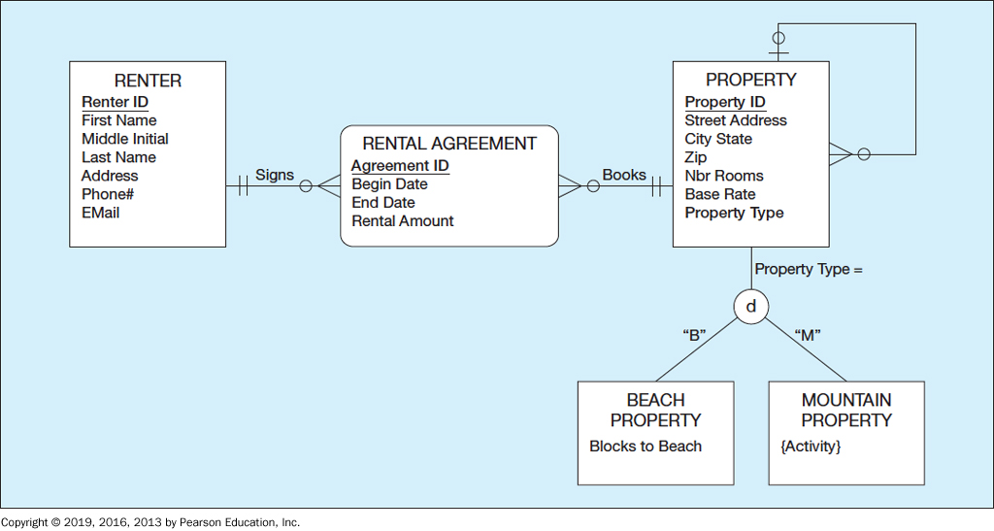

1. Convert/transform the given Vacation Property Rentals EER diagram to tables in the relational database.

Table: Property

|  |  |  |  |  |  |  |  |
| --- | --- | --- | --- | --- | --- | --- | --- |
| PID | StreetAdress | CityState | Zip | NbrRooms | BaseRate | PropertyType | PTID |

Table: Beach Property

|  |  |  |
| --- | --- | --- |
| TypeCode(PK) | BPID(FK01)(PK) | BlocksToBeach |

Table: Mountain Proerty

|  |  |  |
| --- | --- | --- |
| TypeCode(PK) | MPID(FK01)(PK) | Actiivty |

Table: Rential Agreement

|  |  |  |  |  |
| --- | --- | --- | --- | --- |
| PID(FK01)PK | RID(FK02)(PK) | BeginDate | EndDate | RentalAmount |

Table Renter

|  |  |  |  |  |  |  |
| --- | --- | --- | --- | --- | --- | --- |
| RID(PK) | FName | MInitial | LName | Address | Phone | Email |

1. Write down referential integrity constraints in this relations database.

Property.PTID 🡪 Property.PID

Beachproptery.BPID 🡪 Property.PID

Mountian Property.MPID 🡪 Property.PID

RentialAgreement.PID 🡪 Property.PIDRi

Rential Agreement.RID 🡪 Renter.RID

1. Write down funtional dependency analysis for each table

Table Proerty:

PID 🡪 NbrRooms, BaseRate, PropertyType, ZIP(full)

Zip 🡪 StreetAdress, CityState (Trans)

Table: Beach Property

TypeCode, BPID 🡪 Blocks to beach (full)

Table: Mountain Property

TypeCode, MPID 🡪 Activity(full)

Table: Rental Aggreement

PID, RID 🡪 BiginDate, EndDate, RentalAmount (Full)

Table: Renter

RID 🡪 FName, MInitial, LName, Address, Phone, Email (Full)

1. Determine the normal form for each relation/table.

Table: Property (1NF, 2NF)

Table: Beach Propery (1NF, 2NF, 3NF)

Table: MountianProperty (1NF, 2NF, 3NF)

Table: RentalAgreement (1NF, 2NF, 3NF)

Table: Renter(1NF, 2NF, 3NF)

|  |  |  |  |
| --- | --- | --- | --- |
| TableName | 1NF | 2NF | 3NF |
| Property | X | X |  |
| Beach Property | X | X | X |
| MountianProperty | X | X | X |
| Rental Aggreemen | X | X | X |
| Renter | X | X | X |